PROJECT PORTFOLIO
Final Project Design Document

Prepared by:
Chris Sigouin, Matt Hutchinson, and Gwen Harwood
Date Submitted:
Sept 21, 2015

Document Change Control

Date | Authors | Summary of Changes
09/13/2015 | Chris Sigouin | Updated member names and some details regarding the project overall
09/15/2015 | Chris Sigouin | Added “ Technologies Used “ to Section 1.2  Added “About Section” functionality to Sections 1.2 and Section 1.4  Added “Resume” to Section 1.4.9
09/21/2015 | Gwen Harwood | Proofreading – tidied up grammar, syntax and formatting
09/21/2015 | Matthew Hutchinson | Reworked Sections 1.3 and 1.4
09/21/2015 | Chris Sigouin | Reworked descriptions for Sections 1.3 and 1.4
10/17/2015 | Chris Sigouin | Updated Section 1.3.7
10/18/2015 | Chris Sigouin | Updated Sections 2.1 and 2.2
11 /15/2015 | Chris Sigouin | Updated Section 2.1 with DB naming standards

Document Sign-Off
The following people have reviewed and approved the entire content of this document.

Position | Name | Signature | Date

Table of contents

1.0 Background
1.1 Project Team members
1.2 Project Description
1.3 Primary Functions
1.4 Secondary Functions
2.1 Database Design
2.2 Interface Design
2.2.1 Login View
2.2.2 Registration View
2.2.3 Dashboard View
2.2.4 Project Wizard Setup
2.2.5 Project View ( Multi Project View )
2.2.6 Single Project View
2.2.7 User Profile View
2.2.8 About Section View
2.2.9 Journal Manager View
2.2.10 Display View ( External View )
2.2.10 Dropdown Menu

Background

Project Portfolio will allow a developers/designers to add their completed projects and documentation to their own accounts. Once added the web application will produce a web view
tailored specifically for that user to highlight his/her accomplishments and completed work.

1.1 Project Team members

Christopher Sigouin
Matt Hutchinson
Gwen Harwood

1.2 Project Description

BRIEF DESCRIPTION:

A web application/mobile app that will be used to show off projects to employers. Much like a sort of portfolio, it will hold all information pertaining to the project such as milestones, journal entries of progress, technologies used, design document areas, and much more. It could be thought of as a highly organized supplement to any project presentations, PowerPoints, etc.

FEATURES:

The web application is separated into two parts:

FRONT VIEW:

A slick looking view to allow a user to select a project and look further into its details. Once a project is selected, it would allow the person viewing it to know anything about the development of the project (e.g. what was the back end developer working on during day 3 of a particular stage in the project OR what the front end developer decided on for a graphic on the start-up page). Areas that they may choose:

Milestones
Journal Entries (from a developer, from a specific task, etc.)
Design Documentation
Technologies Utilized
BACK END:

Allow entry for all data pertaining to the project. This will require a login to access a user’s account with all projects listed. It will produce a set of ' views ' (that will ultimately be the front end).

Some possible data used:

- Bio and Personal Information
- Journal Entries / Blog / Articles
- Project Details
- Hyperlinks & source code from Github and Bit Bucket ( utilizing their API )

TECHNOLOGIES USED:

- Java ( Spring Framework )
- MySQL
- HTML 5
- CSS 3
- Javascript
- Bootstrap JS Library

1.3 Primary Functions

1.3.1 Login (View)
Users will have a username and password which will be used to login to the system.

1.3.2 User Dashboard (View)
Allow a user to enter information into his/her account. This will be a main view after the user successfully authenticates through the login system. Main functionality of the dashboard will allow access to:

- Project wizard setup
Guides the user through the setup of adding a new project to their profile.
More information under 1.3.3.
- Project listing
This can be a text or thumbnail view of all projects that a user has entered into the system. More information under 1.3.4.
- User Profile
Will allow setup for the user profile. More information under 1.3.5.
- Journal Manager
Will allow a user to access all journal entries for a project. More information under 1.3.6.

1.3.3 Project wizard setup
Takes the user through a guided setup to adding his or her project. It will ask the user for the following information:
Project title and status (In Progress, Completed)
Project images and/or screenshots (limit to 5)
Project description (Text)
Project position (back end developer, front end developer, etc.)
Number of Project Members (Numeric)
Technologies used (Selection that they can add from)
Milestones (Text, can add multiple in same screen)
Related hyperlinks (Text, can add multiple)

1.3.4 Multi Project View
Lists all projects in text or maybe thumbnail view. Allows a user to choose ‘Edit’, ‘View’, or ‘Delete’.
Edit – Will initiate the ‘Wizard setup’ functionality on that particular project. The data that was currently present in the project will show in each step as the user proceeds allowing the user to edit the data, remove it, etc.

View – Will initiate a view mode of the project and display the ‘Single Project View’ mode. This will be used to show the project details in a clean formatted way.

Delete – Will initiate a delete mode and remove the project completely from the system including any data that was linked to it.

1.3.5 User Profile (View)
Will show all information pertaining to the user. The following items will be shown on the user profile view. Each option (except for the calculated ones) will have an edit option to change the value.
User’s Display name
User Image
Biography
Technologies learned
Total Projects Completed (calculated by system)
Total Projects In-progress (calculated by system)

1.3.6 Journal Manager
The journal manager will present the user with a text listing of their projects initially. User selects a project. Then all the milestones are listed for that project. User selects a milestone. All the journal entries are listed. Users at this stage can edit an existing journal entry, delete an entry or add a new entry.

1.3.7 Single Project View
A full view of a single project posted by a user showing details about the project. It will show the following items:
Dates:
Project Start Date
Project Last Edit
Project Completion Date

Project status (In Progress, Completed)
Project images and/or screenshots (limit to 5)
Project description (Text)
Milestones
These can each be links that will allow the viewer to see all journal entries listed under each milestone in a separate view likely.
Project position (back end developer, front end developer, etc.)
Number of Project Members (Numeric)
Technologies used (Selection that they can add from)
Milestones (Text, can add multiple in same screen)
Related hyperlinks (Text, can add multiple)

1.3.8 About Section (Requirement)
In this page, there will be a detailed description of the project. Additionally, instructions will be provided (login/navigation/known issues/bugs). The date and project group members will also be documented on this tab.

1.3.10 Milestones
This will be a listing of the start date to end date milestones for the project itself. A user will initially enter the start date of the project. Once completed milestones are added with a deadline. These are added until the end date is entered.
Milestones will be connected to 'Journal entries '. For each milestone there will be a number of journal entries.
Related attributes:

Dates:
Milestone Name
Start Date
End Date

1.3.11 Journal entries
Allows a user to write detailed article(s) on the specified project as they progress through the project workload. This will provide a personal touch and show how the developer was progressing.
Journal entries will be listed under each milestone entered on the project. A user would be able to enter as many journal entries as they wish.
Related attributes:

Journal Title
Journal Body
Entry Date

1.4 Secondary Functions

1.4.3 Project Search
Front end. Allows a visiting user to search by project technology type, developer/designer name or project name. Initial view of the search page will show a limited number of projects organized by date added.

1.4.1 Contact Me
A view that will allow a user to send contact information to a specific developer

1.4.4 Employer Listings
Allow employers to sign into the site to display job listings at a nominal fee of course

2.1 Database Design

Business Rules / Constraints
1:1
- A user can have only one profile

1: M
- A project can have many hyperlinks associated with it
- A project can have many milestones
- A project status can be assigned to many projects
- A milestone can have many journal entries
- A profile can be linked to many projects

M: N
- A single project can use many technologies
- A technology can be used in many projects

- A profile can have many technologies learned
- A technology can be used with many user profiles

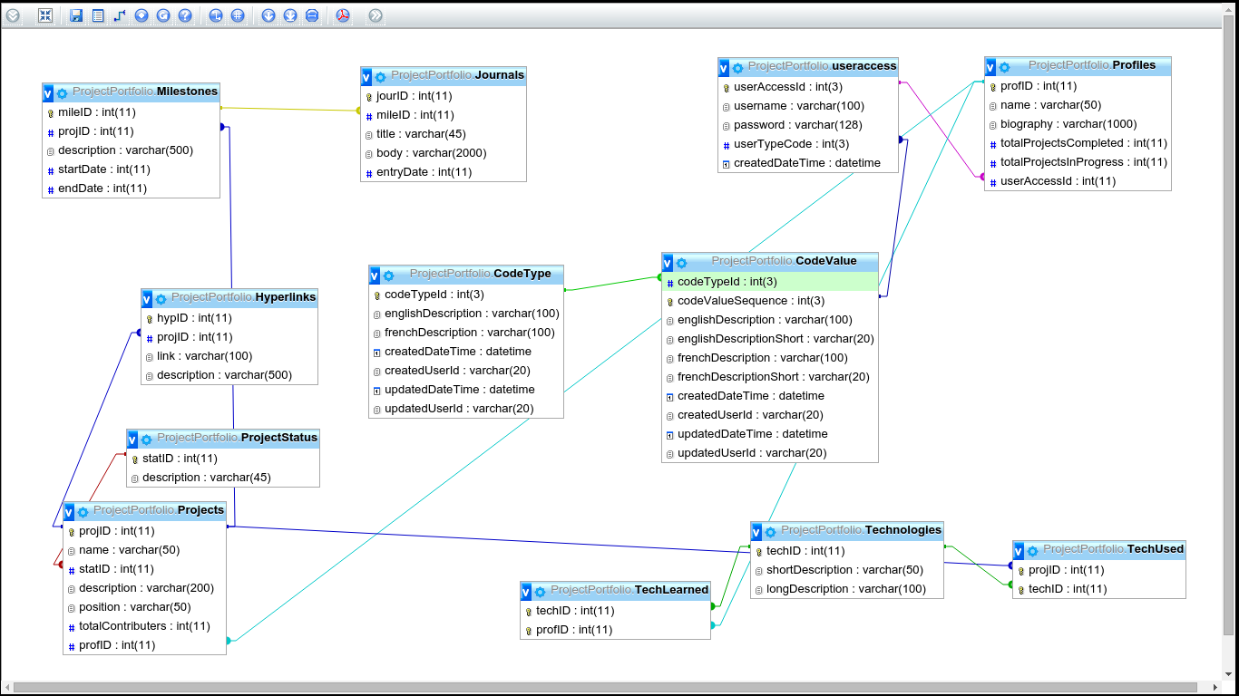

2.2 Interface Design

Provide a mockup of the screens that you expect to use in your project. Also provide a brief description (paragraph of two) describing each of the screens to be used in your program.

This section should provide screen mockups for the screens of the system. As well notes can be provided to clarify the functionality where required

2.2.1 Login View

This view is self-explanatory. User is able either choose ‘Register ‘to submit credentials for entry into the application or provide credentials and choose ‘Submit ‘.

LINKED VIEWS
HYPERLINK | VIEW NAME
Submit Button | Dashboard View
Register Button | Registration View

2.2.2 Registration View

Allows a user to provide credentials for access into the system.

LINKED VIEWS
HYPERLINK | VIEW NAME
Register Now Button | Dashboard View

2.2.3 Dashboard View

c
Dashboard view is the main view of the web application. It allows the user to access most of the functionality. The display section will default to the ‘Project View’ upon initial entry and as a home screen.

LINKED VIEWS
HYPERLINK | VIEW NAME
Drop Down Menu  Display Project  Logout | Display View  Login View
Project View | Project View ( Multi Project View )
Project Wizard | Project Wizard View
User Profile | User Profile View
About Us | About Us View

2.2.4 Project Wizard Setup

Using ‘Bootstrap Accordion’ CSS design, the wizard will allow a user to enter information pertaining to a project. Each section will be inaccessible to the user until the prior section is completed correctly. For example, upon entry into the wizard, the user will only be able to work with ‘Project Title and Status ‘. When the user clicks on the checkbox, it will extend the next section and so on.
Project Wizard will have two modes depending on what view is showing.
ADD MODE – Allows a user to enter details of a new project
EDIT MODE – Allows a user to edit details on a current project that has already been added
LINKED VIEWS
HYPERLINK | VIEW NAME
Drop Down Menu  Display Project  Logout | Display View  Login View
Project View | Project View ( Multi Project View )
Project Wizard | Project Wizard View ( Add Mode )
User Profile | User Profile View
About Us | About Us View

2.2.5 Project View (Multi Project View)

This view will list all projects that are associated with the user’s account. Each project is a hyperlink that will load into the ‘Single Project View ‘of that particular project.

LINKED VIEWS
HYPERLINK | VIEW NAME
Drop Down Menu  Display Project  Logout | Display View  Login View
Project View | Project View ( Multi Project View )
Project Wizard | Project Wizard View ( Add Mode )
User Profile | User Profile View
About Us | About Us View
Project Link ( within Project View ) | Single Project View

2.2.6 Single Project View

Full view of a single project will be listed here. If ‘ Project Wizard ‘ is chosen, it will start the wizard setup process except that the information pertaining to the project that is being viewed will be filled into each corresponding field for the wizard. This will allow the user to edit any information.
The Journal Manager button will only be available within this view.

LINKED VIEWS
HYPERLINK | VIEW NAME
Drop Down Menu  Display Project  Logout | Display View  Login View
Project View Button | Project View ( Multi Project View )
Project Wizard Button | Project Wizard View ( Editing Mode )
User Profile Button | User Profile View
About Us Button | About Us View
Journal Manager Button | Journal Manager View

2.2.7 User Profile View

Allows a user to view, add and edit their user profile information that will be
displayed within the single view of a project. Edit icons are hyperlinks enabling the specific fields allowing a user to edit the contents. The save button will update the database keeping the user on this screen as well.

LINKED VIEWS
HYPERLINK | VIEW NAME
Drop Down Menu  Display Project  Logout | Display View  Login View
Project View | Project View ( Multi Project View )
Project Wizard | Project Wizard View
User Profile | User Profile View
About Us | About Us View

2.2.8 About Section View

The required ‘About Section’.

LINKED VIEWS
HYPERLINK | VIEW NAME
Drop Down Menu  Display Project  Logout | Display View  Login View
Project View | Project View ( Multi Project View )
Project Wizard | Project Wizard View
User Profile | User Profile View
About Us | About Us View

2.2.9 Journal Manager View

This view will only be possible after a user has clicked on ‘Journal Manager‘ while viewing a project in ‘ Single Project View ‘. It will allow the user to review their journal entries under each milestone listed. They will be able to add, edit and/or delete entries.

LINKED VIEWS
HYPERLINK | VIEW NAME
Drop Down Menu  Display Project  Logout | Display View  Login View
Project View | Project View ( Multi Project View )
Project Wizard | Project Wizard View
User Profile | User Profile View
About Us | About Us View
Journal Manager View Button | Journal Manager View

2.2.10 Display View (External View)

This view is the finished view of a project. The ‘Dashboard’ option in the dropdown box will be available only within this view.

LINKED VIEWS
HYPERLINK | VIEW NAME
Drop Down Menu  Dashboard  Logout  Display Project | Dashboard View  Login View  Display View

2.2.11 Dropdown Menu

This menu will be in the corner of every screen. It will allow the user to logout, select a project to display or, if the user is already in a project display view, allow them to go back to the dashboard.
LINKED VIEWS
HYPERLINK | VIEW NAME
Drop Down Menu  Dashboard  Logout  Display Project | Dashboard View  Login View  Display View

